**4. Deploy External DNS and Verify Logs**

--- Reference - <https://github.com/stacksimplify/aws-eks-kubernetes-masterclass/tree/master/08-NEW-ELB-Application-LoadBalancers/08-06-Deploy-ExternalDNS-on-EKS>

**Deploy External DNS**

--- Deploy the manifest

**# Change Directory**

--- **cd 08-06-Deploy-ExternalDNS-on-EKS**

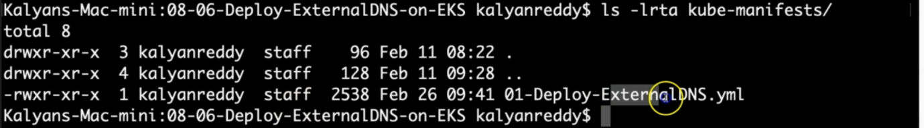

**# Deploy external DNS**

--- **kubectl apply -f kube-manifests/**

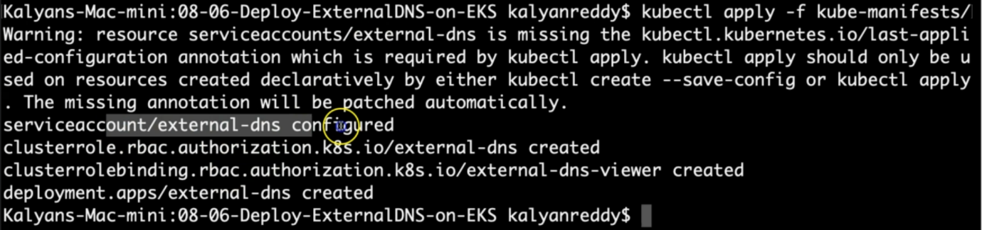

**# List All resources from default Namespace**

--- **kubectl get all**

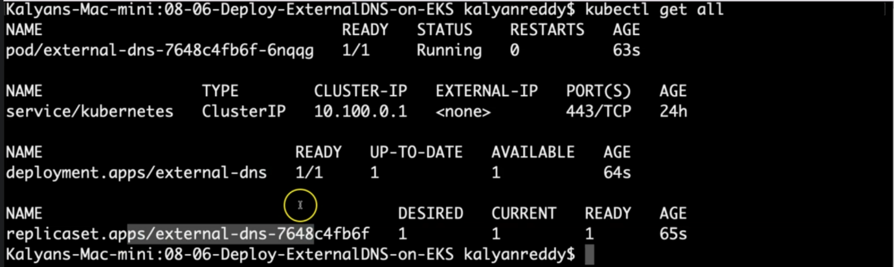

--- **note** - it created, external dns pod, service, deployment, replicaset.

**# List pods (external-dns pod should be in running state)**

--- **kubectl get pods**



--- **note** - you can see the external dns pod.

**# Verify Deployment by checking logs**

--- **kubectl logs -f $(kubectl get po | egrep -o 'external-dns[A-Za-z0-9-]+')**

--- **note** – if you want to verify the external dns logs.

**References**

--- <https://github.com/kubernetes-sigs/external-dns/blob/master/docs/tutorials/alb-ingress.md>

--- <https://github.com/kubernetes-sigs/external-dns/blob/master/docs/tutorials/aws.md>